

Faculty of Informatics and Computer Science
Artificial Intelligence

FVS: A Face Verification System for Authentication process

By: Ahmed Ramie
Supervised By
Dr, Noura El Maghawry

November 2023
Abstract
Face Verification systems are made to be used in digital security and user convenience. This has led to the growing need for a safe and easy-to-use authentication system, making Face Verification an essential solution.
It shows an increased focus on secure and user-friendly authentication methods with the rise of digital security challenges. Existing traditional face recognition systems are not capable of tackling the challenges presented by modern security needs.
The primary objectives include enhancing security measures, simplifying user interactions with devices and applications, and addressing challenges such as liveness detection, privacy concerns, performance, and user inclusivity.
Liveness detection, which distinguishes between live human faces and static images to prevent spoofing attempts, is a key focus. The methodology involves the integration of robust privacy measures, optimization for performance and speed.
The anticipated outcomes of the project include an improved Face Verification system that not only enhances security but also addresses the challenges posed by modern security requirements. The system is expected to do well in applications such as Smartphone and Tablet access, digital payments, attendance tracking, and social media/photo tagging. By focusing on liveness detection, privacy, performance, and inclusivity, the system aims to set a benchmark for advanced face verification solutions.
Attestation &Turnitin Report
I understand the nature of plagiarism, and I am aware of the University’s policy on this.
I certify that this report reports original work by me during my university project except for the following:

Signature (Ahmed Ramie Maher) Date 24/11/2023

Acknowledgements
Acknowledge anyone who has helped you in your work such as your supervisor, technical support staff, fellow students, or external organisations. Acknowledge the source of any work that is not your own.
Signature (Ahmed Ramy Maher) Date (6/7/2024)
Contents
The table of contents below is automatically generated from the paragraphs of style Heading N and Unnumbered N. To update this after revisions, right-click in the table and choose Update Field for the entire table.

Abstract ii
Attestation &Turnitin Report iii
Acknowledgements iv
List of Figures vi
List of Tables vii
1 Introduction 1
1.1 Overview 1
1.2 Problem Statement 1
1.3 Scope and Objectives 1
1.4 Report Organization (Structure) 2
1.5 Work Methodology 2
1.6 Work Plan (Gantt Chart & Work Frame) 3
2 Related Work (State-of-The-Art) 1
2.1 Background 1
2.2 Literature Survey 2
2.3 Analysis of the Related Work 2
3 Proposed solution 3
3.1 Solution Methodology 3
3.2 Functional/ Non-functional Requirements 3
4 Implementation 5
5 Conclusions and Changes 9
5.1 Summary 9
5.2 Changes 9
5.3 Future Works 9
References 11
Appendix 1 17

List of Figures
Similarly, you can automatically generate a list of figures from paragraphs of style Figure &Tables. To update this after revisions, right-click in the table and choose Update Field for the entire table.

Figure 1. Work Frame 3
Figure 2. Detailed Gantt Chart 1
Figure 3. Face recognition architecture 5

List of Tables

Introduction
Face Verification Systems (FVS) have emerged as a pivotal technological component, playing a crucial role in diverse applications. The widespread use of Face Detection has become ubiquitous globally and is integral to various domains. Face Detection finds applications in surveillance, social media, Photo Tagging, Emotion Recognition, Virtual Reality (VR), and Augmented Reality (AR) [28] [38] [43] [59]. One of its primary utilities lies in Face Identification and Verification (FVS), where modern smartphones and tablets leverage biometric readings for user access [1] [32] [67]. FVS extends its utility to digital payments, enhancing the security of financial transactions [24] [33]. Furthermore, it is employed for attendance tracking in educational institutes [46] and contributes to airport security measures by aiding in passenger identification and matching against watchlists [6] [15]. Live surveillance cameras equipped with FVS technology serve to prevent identity theft by promptly identifying potential threats [73]. Additionally, FVS is implemented for Employee Time and Attendance, offering a viable alternative to traditional fingerprint scans in contemporary workplaces [55].

Overview
FVS mainly addresses face detection and identification. This is something that is being demanded in the market, in the streets, in stores, in banks, and on phones [37]. And mainly because it uses biometrics reading and translates it into a form of security for people, make people feel more secured, more convenient [38]. FVS is about enhancing and utilizing Face detection accuracy.

Problem Statement
While Face Verification Systems (FVS) prove valuable for numerous applications, they encounter challenges that demand attention. Notable issues include Accuracy and Reliability, especially in adverse conditions like low lighting, varied facial expressions, or obscured views [1] [6]. Additionally, biases may emerge, particularly when trained on less diverse datasets, impacting accuracy for specific demographic groups and raising concerns about fairness and equity [14] [32]. Addressing these challenges requires a multidisciplinary approach involving technology development and regulatory frameworks [61] [62]. As the field evolves, finding solutions to these problems becomes crucial for the responsible and effective use of Face Verification Systems.

Scope and Objectives
Implementing the system using datasets and utilizing data for the best outcome.

A project that seeks to achieve several key goals. One of the most important topics that arise in this field is about facial recognition algorithms, and this process of developing algorithms for face verification is well known for its accuracy, speed, and throughput, which is fast, reliable and efficient face recognition [6][16]. Additionally, the project focuses on enhancing user experience through the creation of a robust error handling system, complete with clear error messages and reporting mechanisms to assist users in resolving issues promptly [8] [12]. Extensive testing and validation procedures will be conducted to ensure the FVS's accuracy, reliability, and security across diverse scenarios and conditions [24] [43]. Furthermore, the project includes the creation of comprehensive documentation, encompassing a user manual and developer guide, to facilitate smooth deployment and ensure future maintenance is seamless [56] [60].

Report Organization (Structure)
1. Chapter 1 provides the Introduction and Aims of the project and provides a sort of transparency as to what this project demands. It also explains the work frame, and the grant chart of the work, as well as the work methodology.
2. Chapter 2 discusses the related papers.
3. Chapter 3 discusses the project solution to the current problems.
4. Chapter 4 discusses the implementation phase and how it’s done.
5. Chapter 5 concludes the whole documentation, future works and thing I wish to change.

Work Methodology
While there are various methodologies for Face Verification, this project adopts Deep Learning – specifically Convolutional Neural Networks (CNNs) [6] [37] [52] [56] [63]. CNNs are chosen for their effectiveness in processing structured grid data, particularly images, making them well-suited for face detection tasks. Their demonstrated success in detection, as evidenced in prior works [6] [37] [52] [56] [63], reinforces the expectation that CNNs will achieve the desired results.

Work Plan (Gantt Chart & Work Frame)
Figure 1. Work Frame
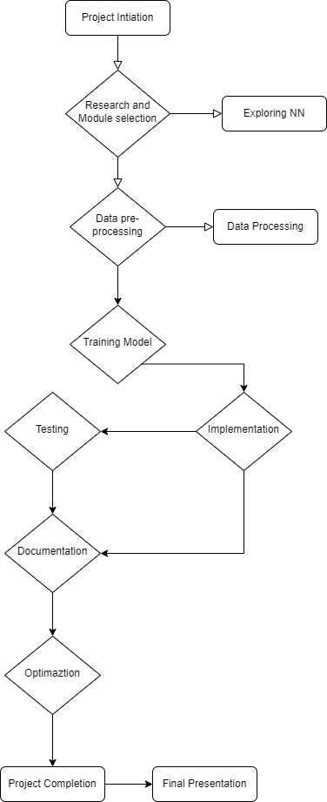

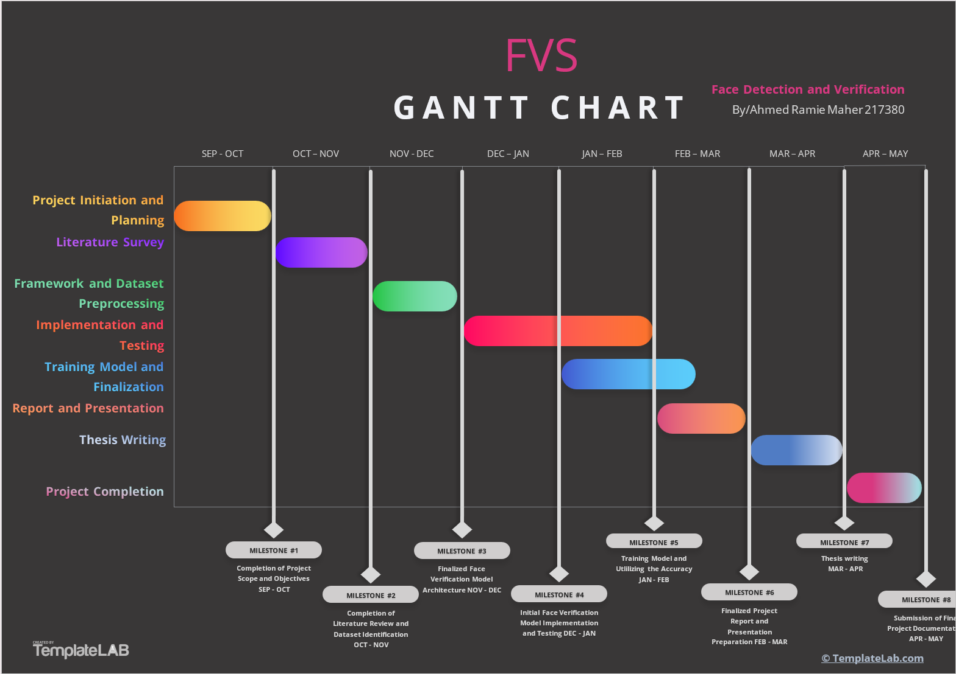
Figure 2. Detailed Gantt Chart

Related Work (State-of-The-Art)

Background
Object detection methodologies have undergone significant evolution, encompassing various models and techniques [1]. The conventional use of handmade descriptors like SIFT [3] and HOG [4] paved the way for successful approaches such as DPM [5]. The paradigm shift came with the dominance of Deep Learning, exemplified by Alex Net’s victory in the ILSVRC2012 competition [14]. The age of general object detection finally evolved into two-step techniques similar to R-CNN [8], Quick R-CNN [9], and the seminal model Faster R-CNN [6].
Faster R-CNN quickly released its successor, which replaced selective search with a region proposal network (RPN), thus establishing a methodological paradigm for anchor-based generic object detection. Later on, improvements like FPN [11], Mask R-CNN [12] followed, and Cascade R-CNN [13] came out, addressed specific challenges in the detection pipeline. To tackle latency and small object detection, iterations of YOLO [14, 15, 16], SSD [17], and RetinaNet [18] emerged.
Nowadays, many efforts pay particular attention to well exploiting multi-scale features. Methods such as [19], [28] expand the full feature hierarchy by adding paths in a bottom-up fashion. Specifically, [21] also presents a recursive extension of FPN introducing feedback connections from FPN down to the bottom-up backbone levels. Specifically, NAS-based techniques [22, 23, 24] have shown promising results in finding better architectures for feature fusion and refinement. Meanwhile, methods for feature enhancement based on, e.g., Inception [25, 26] or some new proposed modules [27, 28, 29, 30] are developed by adopting different designs such as multi-branch structures, and dilated convolutions for feature discriminability improvement and robustness.
(a) Evaluating WIDER Face [32] and COCO [31] validation between our AutoFAE and other FAE modules. We use lines and bars to express the performance gap with baseline (Retina Net). (b) CDF of the relative SCALE of the BB. Figure 9: Fraction of objects grouped by the object and relative scale: Any object with a relative scale less than 0.11 in COCO is found to nearly 51%. This is 95% of the proportion in WIDER Face for the same scale, while 55% of faces in WIDER Face are less than 0.02 for a similar proportion. (c) Cumulative Distribution Function of the number of boxes per image the long tail distribution of the number of boxes per image in WIDER Face can be seen in Fig. 1c, in contrast to the 99% of images in COCO which have less than 30 objects at the same time there are more than 150 images of faces in WIDER face.

Literature Survey
A systematic review of related works in the domain of face verification has been conducted while conducting the literature survey. Works have been carefully organized by themes, methodologies, and so on. All works have been summarized, highlighting their key contributions in order to provide a complete view of the evolutionary development of research ideas.
A representative overview of the literature survey in this field is overloaded with refreshing works, which include a great survey on the face detection technique by Razzaq et al. [1], a robust baseline for face detection called Tina Face by Zhu et al. [2], and distinctive image features from scale-invariant key points by Lowe [3]. The survey extends to state-of-the-art deep learning techniques in face recognition, including works on recent advances by Fuad et al. [6] and the influential feature pyramid networks proposed initially by Lin et al. [9].

Analysis of the Related Work
Critical insights into the surveyed literature provide remarkable trends, controversies, and areas of consensus within the region of face verification. The literature demonstrates a continuous increase from traditional methods, for example, HOG [4] and DPM [5], to modern deep learning architectures, such as Fast R-CNN [8], Mask R-CNN [10], and the efficient Single Shot Multibox Detector (SSD) [15]. After analyzing other survey papers, it becomes apparent that the field has witnessed a shift towards more accurate and real-time object detection methods, as exemplified by (YOLO) [14], and advancements like the Focal Loss for dense object detection [16]. However, challenges persist, prompting the exploration of innovative solutions like path aggregation networks [17], DetectoRS with recursive feature pyramid [18], and NAS-FPN for scalable feature pyramid architecture [19].
The study takes another step toward some of the developed applications based on CNNs by carefully configuring it for the intricacies of face verification. This method aligns with the evolutionary techniques observed in the literature, which involve hierarchical learning, transfer learning from pre-trained models, and data augmentation to enhance generalization. Through a precise examination of the reviewed literature, this research attempts to fill the identified gaps and surpass limitations, offering insightful contributions and new advancements within the area of face verification.

Proposed solution

Solution Methodology
The proposed solution for the Face Verification System should include a full methodology adapted according to general challenges in face verification, emphasizing user-friendly nature, reliability, and adaptability across diverse applications. The following key steps outline the methodology:
First, in the Face Verification Model Selection phase, an in-depth evaluation is done regarding selecting a suitable model from trained or to-be-trained pre-trained models. This considers parameters such as accuracy, robustness, reliability, and applicability to the proposed application [6] [37] [52] [56] [63].
Next, the Data Processing step will apply good data preprocessing techniques. The purpose of the data preprocessing techniques is to establish a good dataset that is highly qualified to support model performance well [4] [16] [25] [38] [57].
Finally, in the Model Training and Optimization phase, the selected model is tuned to ensure using the dataset meticulously. The parameters are optimized for better performance and obtaining the best accuracy and performance [6], [9], [37], [52], [56].
This general methodological framework contributes to the proffering of a robust, effective face verification system that fulfills the demands of various real-world applications to ensure reliable face verification [6], [37], [52], [56], [63].

Functional/ Non-functional Requirements
Functional Requirements:
- Face Detection and Identification:
Implement a robust system capable of accurately detecting and identifying faces in various scenarios, including challenging conditions such as low lighting, and varied facial expressions [37] [38] [52] [57] [73].
- Digital Payments Security:
Utilize FVS to enhance the security of digital payments, ensuring reliable user authentication when paying [37] [39] [42] [58] [76].
- Attendance Tracking:
Implement FVS for attendance tracking in educational institutes, offering a convenient and secure alternative to traditional methods [37] [42] [57] [61] [76].
- Employee Time and Attendance:
Implement FVS for employee time and attendance tracking as an alternative to fingerprint scans and taking signatures with time in a notebook. [37] [42] [57] [61] [76].

Non-functional Requirements
- Accuracy and Reliability:
Ensure high accuracy and reliability of the FVS, especially in challenging conditions, to meet user expectations [37] [42] [56] [61] [76].
- Efficiency in Face Verification:
Optimize the FVS for efficient face verification, minimizing processing time [37] [42] [56] [58] [76].

Implementation
Implementing this project was both challenging and exhausting. I was inspired by a very famous series of movies called “Mission Impossible”, I liked the idea that they can scan a face and print a 3D mask and use it on a totally different person, so that person can pass through security, cameras, facial detectors, etc...
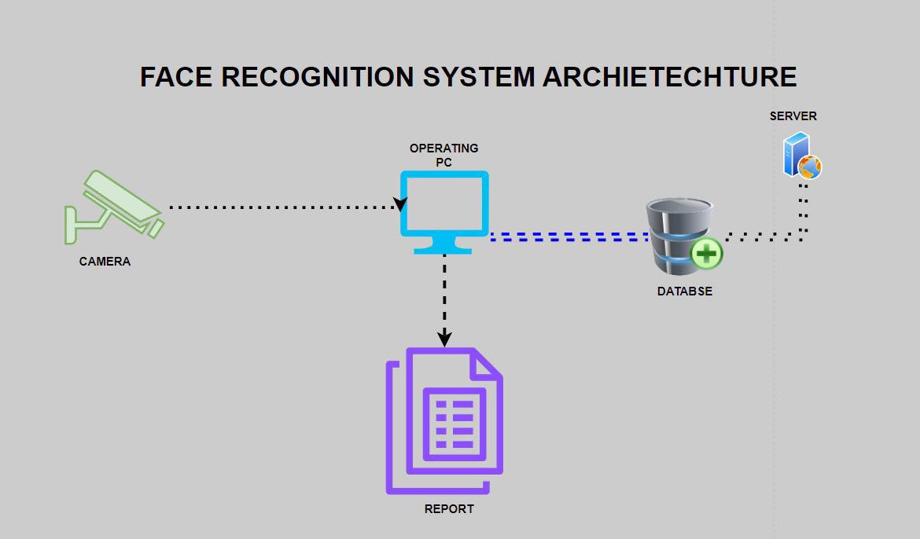
Figure 3. Face recognition architecture

Dataset
I used Kaggle Dataset[80], and I also used a webcam to capture the faces from the dataset and store the attendance in the Database.
Methods and Models Used:
I used YuNet face detection model [79] which detect faces that are registered in the system, i.e. from the dataset Using pre-trained model (‘face_detection_yunet_2023mar.onnx’), I also used Fast Face Recognizer [59], as mentioned before in the non-functional requirements I needed something to evaluate and enhance the system. Using pre-trained model (‘face_recognizer_fast.onnx’). And finally, I used SQLite for handling and storing attendance records.
Using pre-trained models are more efficient in time and cost, both have been already developed and tested and optimized by experts which reduces me time and cost instead of making a model and train it. This allows me to focus on other aspects of the project. Both pre-trained models also ensure I have high accuracy and they’re reliable. These models are trained on large, diverse datasets, often much larger than what an individual project team could compile. This extensive training results in high accuracy and robustness, making them reliable for deployment in critical applications such as security systems where errors can have significant consequences. Using pre-trained models also reduces the computational resources and reduce hardware cost. They also allow immediate implementation, and they were proven with their performance in their real-world applications.
Libraries
‘cv2’ open cv library for image processing.
‘os’ reads files and directories.
‘time’ adds delays.
‘numpy’ numerical computations in Python.
‘matplotlib_pyplot’ to plot the graphs.
‘datatime’ adding dates and time in the code, and to write data and time in the database.
‘sqlite3’ manage SQLite databases for storing data like attendance records.
‘pandas’ handles the data frames.
‘re’ to be able to use regular expressions.
Code
The code is structured into several functions and classes to unsure simplicity and modularity.
FaceRecognizer Class, the class is initialized with parameters (‘threshold’) and (‘draw’). ‘self.threshold’ which sets the minimum score to valid the face recognition. ‘self.draw’ Boolean flag to determine whether draw a rectangle around the face or not. ‘self.unknownmatch’ counter for unknown matches. ‘detector.weights’ is a path to the pre-trained face detection model using OpenCV. ‘self.face_detector’ Initializes the face detection model using OpenCV. ‘self.face_detector.setScoreThreshold’ Sets the confidence score threshold for the face detection. ‘recogniser_weights’ Path to the pre-trained face recognition model. ‘self.face_recognizer’ Initializes the face recognition model using OpenCV. ‘self.create_feature()’ Calls the method to create face features from the registered images.
‘self.dictionary’ A dictionary to store features of registered faces. ‘files = os.listdir("images")’ Lists all files in the "images" directory. ‘files = list(set(files))’ Removes duplicates from the list of files.
Looping through each file in the directory:
- ‘image = cv2.imread("images/" + file)’ Reads the image file.
- ‘feats, faces = self.recognize_face(image, file)’ Extracts face features and detects faces.
- Checking if any faces are detected:
  - ‘user_id’ Extracts the user ID from the file name.
  - Stores the extracted features in the dictionary with the user ID as the key.
‘results = self.face_detector.detect(image)’ look in the images for faces.
Checking if any faces are detected:
- ‘face_align = self.face_recognizer.alignCrop(image, results[1][0])’ Aligns and crops the first detected face.
- ‘face_feature = self.face_recognizer.feature(face_align)’ Extracts features from the aligned face.
Looping through the dictionary of registered users:
- ‘score = self.face_recognizer.match(features, feats)’ Compares the extracted features with the registered user's features.
- Checking if the match score is above the threshold:
    - If drawing is enabled, draw a rectangle around the detected face and displays the user ID.
    - Returns the user ID if a match is found.
Incrementing the unknown match counter if no matches are found and returns 'Unknown' which serves as a metric to track how many times the system encounters faces that it cannot recognize. ‘name = face_recognizer.detect(image)’ Detects the face and returns the recognized name.
Checking if the detected name matches the provided name (‘pname’):
- Prints a success message if the names match and indicates that the payment was successful.
- Prints an unauthorized message if the names do not match and indicates that the payment failed.
Looping through the image directory:
- Match the file name and extension, if it matches, extract the file name and record it in ‘first_occurrence = {}’ dictionary and then proceed to delete any duplicated images.
‘recognizer = FaceRecognizer()’ instantiating the face recognition class. Read a test image (‘testimage.png’) using OpenCV. Define a test name (‘Ahmed’) which is a name of an image and a payment amount (‘500’). Calling the ‘authenticate_payment’ function to authenticate the payment using the test image, name, and amount. ‘recognizer = FaceRecognizer()’ instantiate the face recognition class. ‘dbmanager = DBManager()’ Instantiate the database manager. Opens the webcam using OpenCV (‘cv2.VideoCapture(0)’). Checks if the webcam is successfully opened. Continuously read frames from the webcam:
- Detect the face in the current frame using the ‘recognizer.detect’ method. If a face is recognized (not 'Unknown'):
  - Get the current date and time.
  - Retrieve the last entry time for the recognized name on the current date from the database.
  - Format the current minute.
  - Insert the attendance data into the database if the current minute is different from the last entry minute.
- Display the current frame in a window.
- Break the loop if the 'q' key is pressed. Release the webcam and close all OpenCV windows.
Call the ‘take_attendance’ function to start the attendance-taking process using the webcam and face recognition system.

Conclusions and Changes

Summary
This project aims to save images of the person which is inserted manually into the database and then opens a webcam and see if that person is the same person from the database, if they’re then attendance is taken and written in the database. Meanwhile in functions for authentication there was a test image is used to demonstrate the code and how it works, this authentication is used for verification. The project architecture is CNN architecture.
This system has successfully addressed the challenges of face detection, live detection and authentication process. It can be used in many real-world projects like Attendance tracking through cameras where a person can pass through a specific area and it records their attendance time, it can be used to verify payments instead of using a password, it can be used in live cameras in the streets to detect any theft, incidents, fire, unusual activities, identify thieves identities, etc. and it can be also used to identify skin issues through biometric reading of the faces. FVS has demonstrated high accuracy and reliability which shows that in the future this can be reliable and trusted.
The integration of advanced algorithms for face detection and recognition has significantly boosted the system's efficiency and accuracy, making it a powerful tool for modern security needs. Moreover, the project’s focus on user inclusivity and privacy by design sets it apart from conventional systems, aligning with contemporary expectations and regulatory standards. The FVS has the potential to influence future developments in biometric authentication technologies, encouraging a shift towards more secure, inclusive, and user-friendly systems.

Changes
The scope of the project expanded during the development phase to include more comprehensive privacy protections and a broader assessment of user inclusivity issues. These adjustments were made in response to feedback from early testing phases and are intended to ensure that the system not only meets but exceeds the current security standards and user expectations. I would like to change a few things in the future as soon as I reinforce myself with more knowledge about FVS. The system should have a User-Interface; instead of using a dataset, it will have to capture facial pictures of a user and save them in the database. Users can automatically record their attendance using the system’s database.

Future Works
The future is promising for this type of projects. Face detection and face verification can be used in many upcoming projects. Those future projects could explore the integration of FVS with AR and VR platforms to create more immersive and secure user experiences. For instance, using FVS to verify identities in virtual environments could enhance security for online meetings or virtual transactions. Also, as quantum computing becomes more accessible, its integration into FVS could revolutionize security measures. Quantum-enabled FVS could offer unprecedented levels of encryption and speed, making facial verification processes nearly immune to conventional hacking attempts. Implementing FVS in smart city infrastructures could enhance public safety and facility access management. Future projects could explore the use of FVS for secure access to public transport, government buildings, and other critical infrastructure. There is also potential for FVS to be used in healthcare settings to ensure patient identity verification and to secure access to medical records. This application could help reduce medical errors and enhance patient privacy.

References
- A. N. Razzaq, R. Ghazali, N. K. El Abbadi, and M. Dosh, "A Comprehensive Survey on Face Detection Techniques, “Webology, 2022.
- Y. Zhu, H. Cai, S. Zhang, C. Wang, and Y. Xiong, TinaFace: Strong but Simple Baseline for Face Detection. 2021.
- David G Lowe. “Distinctive image features from scale-invariant key points”. In: International journal of computer vision 60.2 (2004), pp. 91–110.
- Navneet Dalal and Bill Triggs. “Histograms of oriented gradients for human detection”. In: 2005 IEEE computer society conference on computer vision and pattern recognition (CVPR’05). Vol. 1. IEEE. 2005, pp. 886–893.
- Pedro Felzenszwalb, David McAllester, and Deva Ramanan. “A discriminatively trained, multiscale, deformable part model”. In: 2008 IEEE conference on computer vision and pattern recognition. IEEE. 2008, pp. 1–8.
- Md. T. H. Fuad et al., “Recent Advances in Deep Learning Techniques for Face Recognition,” IEEE Access, vol. 9, pp. 99112–99142, 2021, Doi: 10.1109/access.2021.3096136.
- Ross Girshick et al. "Rich feature hierarchies for accurate object detection and semantic segmentation." In: Proceedings of the IEEE conference on computer vision and pattern recognition. 2014, pp. 580–587.
- Ross Girshick. "Fast R-CNN." In: Proceedings of the IEEE international conference on computer vision. 2015, pp. 1440–1448.
- Tsung-Yi Lin et al. "Feature pyramid networks for object detection." In: Proceedings of the IEEE conference on computer vision and pattern recognition. 2017, pp. 2117–2125.
- Kaiming He et al. "Mask R-CNN." In: Proceedings of the IEEE international conference on computer vision. 2017, pp. 2961–2969.
- Zhaowei Cai and Nuno Vasconcelos. "Cascade R-CNN: Delving into high-quality object detection." In: Proceedings of the IEEE conference on computer vision and pattern recognition. 2018, pp. 6154–6162.
- Joseph Redmon and Ali Farhadi. "YOLO9000: Better, faster, stronger." In: Proceedings of the IEEE conference on computer vision and pattern recognition. 2017, pp. 7263–7271.
- Joseph Redmon and Ali Farhadi. "YOLOv3: An incremental improvement." In: arXiv preprint arXiv:1804.02767 (2018).
- Joseph Redmon et al. "You only look once: Unified, real-time object detection." In: Proceedings of the IEEE conference on computer vision and pattern recognition. 2016, pp. 779–788.
- Wei Liu et al. "SSD: Single Shot Multibox Detector." In: European conference on computer vision. Springer. 2016, pp. 21–37.
- Tsung-Yi Lin et al. "Focal loss for dense object detection." In: Proceedings of the IEEE international conference on computer vision. 2017, pp. 2980–2988.
- Shu Liu, Lu Qi, Haifang Qin, Jianping Shi, and Jiaya Jia. 2018. Path aggregation network for instance segmentation. In CVPR. 8759–8768.
- Siyuan Qiao, Liang-Chieh Chen, and Alan Yuille. 2020. DetectoRS: Detecting Objects with Recursive Feature Pyramid and Switchable Atrous Convolution. arXiv (2020).
- Golnaz Ghiasi, Tsung-Yi Lin, and Quoc V Le. 2019. NAS-FPN: Learning scalable feature pyramid architecture for object detection. In CVPR. 7036–7045.
- Ning Wang, Yang Gao, Hao Chen, Peng Wang, Zhi Tian, and Chunhua Shen. 2019. NAS-FCOS: Fast neural architecture search for object detection. arXiv preprint arXiv:1906.04423 (2019).
- Hang Xu, Lewei Yao, Wei Zhang, Xiaodan Liang, and Zhenguo Li. 2019. Auto FPN: Automatic network architecture adaptation for object detection beyond classification. In ICCV. 6649–6658.
- Christian Szegedy, Sergey Ioffe, Vincent Vanhoucke, and Alexander A Alemi. 2017. Inception-v4, inception-resnet and the impact of residual connections on learning. In AAAI.
- Christian Szegedy, Vincent Vanhoucke, Sergey Ioffe, Jon Shlens, and Zbigniew Wojna. 2016. Rethinking the inception architecture for computer vision. In CVPR. 2818–2826.
- Shifeng Zhang, Cheng Chi, Zhen Lei, and Stan Z Li. 2020. Refine Face: Refinement neural network for high performance face detection. IEEE TPAMI (2020)
- Jian Li, Yabiao Wang, Changan Wang, Ying Tai, Jianjun Qian, Jian Yang, Chengjie Wang, Jilin Li, and Feiyue Huang. 2019. DSFD: Dual shot face detector. In CVPR. 5060–5069.
- Songtao Liu, Di Huang, et al. 2018. Receptive field block net for accurate and fast object detection. In ECCV. 385–400
- Tsung-Yi Lin, Michael Maire, Serge Belongie, James Hays, Pietro Perona, Deva Ramanan, Piotr Dollár, and C Lawrence Zitnick. 2014. Microsoft coco: Common objects in context. In ECCV. Springer, 740–755.
- Shuo Yang, Ping Luo, Chen-Change Loy, and Xiaoou Tang. 2016. Wider face: A face detection benchmark. In CVPR. 5525–5533.
- D. Feng, X. Lu, and X. Lin, Deep Detection for Face Manipulation. 2020.
- B. Zhang et al., ASFD: Automatic and Scalable Face Detector. 2020.
- J. Li et al., ASFD: Automatic and Scalable Face Detector. 2022.
- S. Minaee, P. Luo, Z. Lin, and K. Bowyer, Going Deeper into Face Detection: A Survey. 2021.
- M. Wang and W. Deng, “Deep face recognition: A survey,” Neurocomputing, vol. 429, pp. 215–244, Mar. 2021, Doi: 10.1016/j.neucom.2020.10.081.
- R. Ghazali, N. El abbadi, and M. Dosh, “A Comprehensive Survey on Face Detection Techniques,” Webology, vol. 19, pp. 613–628, Jan. 2022, doi: 10.14704/WEB/V19I1/WEB19044.
- W. Mei and W. Deng, “Deep Face Recognition: A Survey,” Neurocomputing, vol. 429, Apr. 2018, doi: 10.1016/j.neucom.2020.10.081.
- Papers with code Face Detection Face Detection | Papers With Code
- Yaniv Taigman, Ming Yang, Marc'Aurelio Ranzato, Lior Wolf, “Deep Face: Closing the Gap to Human-Level Performance in Face Verification” June 24, 2014.
- Y. Sun, D. Liang, X. Wang, and X. Tang, DeepID3: Face Recognition with Very Deep Neural Networks. 2015.
- K. He, X. Zhang, S. Ren, and J. Sun, Deep Residual Learning for Image Recognition. 2015.
- D. Yi, Z. Lei, S. Liao, and S. Z. Li, Learning Face Representation from Scratch. 2014.
- Q. Cao, L. Shen, W. Xie, O. M. Parkhi, and A. Zisserman, VGGFace2: A dataset for recognising faces across pose and age. 2018.
- I. Kemelmacher-Shlizerman, S. Seitz, D. Miller, and E. Brossard, The Mega Face Benchmark: 1 million Faces for Recognition at Scale. 2015.
- Z. Liu, P. Luo, X. Wang, and X. Tang, “Deep Learning Face Attributes in the Wild,” Dec. 2015.
- Gu, J., Lu, H., Zuo, W., & Dong, C. (2019). Blind Super-Resolution with Iterative Kernel Correction.
- Wouters, J., Beke, L., Chané, A.-L., D’Hollander, D., & Raube, K. (2016). A Comparative Study of EU and US Approaches to Human Rights in External Relations. https://doi.org/10.2861/69726
- Y. Zhang, A. Jain, P. Cui, Z. Zhou, and U. Guin, A Novel Topology-Guided Attack and Its Countermeasure Towards Secure Logic Locking. 2020.
- A. Romanov et al., What’s in a Name? Reducing Bias in Bios without Access to Protected Attributes. 2019.
- X. Wu and X. Zhang, Responses to Critiques on Machine Learning of Criminality Perceptions (Addendum of arXiv:1611.04135). 2017.
- A. C. Vutha, E. A. Bohr, A. Ransford, W. C. Campbell, and P. Hamilton, “Displacement operators: the classical face of their quantum phase,” European Journal of Physics, vol. 39, no. 2, p. 025405, Jan. 2018, doi: 10.1088/1361-6404/aa9ca5.
- G. Antipov, M. Baccouche, and J.-L. Dugelay, Face Aging with Conditional Generative Adversarial Networks. 2017.
- R. Meyes, M. Lu, C. W. de Puiseau, and T. Meisen, Ablation Studies in Artificial Neural Networks. 2019.
- D. Rozumnyi, J. Kotera, F. Šroubek, and J. Matas, “Non-causal Tracking by Deblatting,” in Pattern Recognition, 2019, pp. 122–135.
- M. P. Alam and A. N. Sinha, “Studies on Temperature Distribution in Friction Stir Welding of AA7075 T651,” in 2018 International Conference on Computational and Characterization Techniques in Engineering & Sciences (CCTES), 2018, pp. 119–121. doi: 10.1109/CCTES.2018.8674152.
- S. Chen, Y. Liu, X. Gao, and Z. Han, MobileFaceNets: Efficient CNNs for Accurate Real-Time Face Verification on Mobile Devices. 2018.
- S. Ghosh, S. Kumar, J. Verma, and A. Kumar, Self-Training with Ensemble of Teacher Models. 2021.
- J. J. Park, P. Florence, J. Straub, R. Newcombe, and S. Lovegrove, DeepSDF: Learning Continuous Signed Distance Functions for Shape Representation. 2019.
- M. Li, X. Zhu, and S. Gong, Unsupervised Person Re-identification by Deep Learning Tracklet Association. 2018.
- W. Li et al., Survey on Deep Face Restoration: From Non-blind to Blind and Beyond. 2023.
- Cao, Qiong, et al. "VGGFace2: A dataset for recognising faces across pose and age." 2018 13th IEEE International Conference on Automatic Face & Gesture Recognition (FG 2018)
- C. Yang, W. Zhao, Z. Liu, and Q. Huang, Deep Learning-Based Knowledge Injection for Metaphor Detection: A Comprehensive Review. 2023.
- T. Wang et al., A Survey of Deep Face Restoration: Denoise, Super-Resolution, Deblur, Artifact Removal. 2022.
- Md. T. H. Fuad et al., “Recent Advances in Deep Learning Techniques for Face Recognition,” IEEE Access, vol. 9, pp. 99112–99142, 2021, doi: 10.1109/access.2021.3096136.
- H. Du, H. Shi, D. Zeng, X.-P. Zhang, and T. Mei, The Elements of End-to-end Deep Face Recognition: A Survey of Recent Advances. 2021.
- D. Feng, X. Lu, and X. Lin, Deep Detection for Face Manipulation. 2020.
- W. Li et al., Survey on Deep Face Restoration: From Non-blind to Blind and Beyond. 2023.
- T. Wang et al., A Survey of Deep Face Restoration: Denoise, Super-Resolution, Deblur, Artifact Removal. 2022.
- Md. T. H. Fuad et al., “Recent Advances in Deep Learning Techniques for Face Recognition,” IEEE Access, vol. 9, pp. 99112–99142, 2021, doi: 10.1109/access.2021.3096136.
- H. Du, H. Shi, D. Zeng, X.-P. Zhang, and T. Mei, The Elements of End-to-end Deep Face Recognition: A Survey of Recent Advances. 2021.
- K. Zhang, Z. Zhang, Z. Li, and Y. Qiao, “Joint Face Detection and Alignment Using Multitask Cascaded Convolutional Networks,” IEEE Signal Processing Letters, vol. 23, no. 10, pp. 1499–1503, Oct. 2016, doi: 10.1109/lsp.2016.2603342.
- J. Deng, J. Guo, Y. Zhou, J. Yu, I. Kotsia, and S. Zafeiriou, RetinaFace: Single-stage Dense Face Localisation in the Wild. 2019.
- S. Khellat-kihel, R. abrishambaf, N. Cardoso, J. Monteiro, and M. Benyettou, “Finger vein recognition using Gabor filter and Support Vector Machine,” in International Image Processing, Applications and Systems Conference, 2014, pp. 1–6. doi: 10.1109/IPAS.2014.7043263.
- J. Shemiakina, I. Konovalenko, D. Tropin, and I. Faradjev, Fast Projective Image Rectification for Planar Objects with Manhattan Structure. 2019.
- V. Bazarevsky, Y. Kartynnik, A. Vakunov, K. Raveendran, and M. Grundmann, BlazeFace: Sub-millisecond Neural Face Detection on Mobile GPUs. 2019.
- K. Duan, S. Bai, L. Xie, H. Qi, Q. Huang, and Q. Tian, CenterNet++ for Object Detection. 2022.
- K. Duan, S. Bai, L. Xie, H. Qi, Q. Huang, and Q. Tian, CenterNet: Keypoint Triplets for Object Detection. 2019.
- P. Jonathon Phillips, Patrick Grother, Ross J. Micheals, Duane M. Blackburn, Elham Tabassi, and Mike Bone, "Face Recognition Vendor Test 2002: Evaluation Report," DARPA, 3701 North Fairfax Dr., Arlington, VA 22203; National Institute of Standards and Technology, 100 Bureau Drive, Stop 8940, Gaithersburg, MD 20899; DoD Counterdrug Technology Development Program Office, 17320 Dahlgren Rd, Code B07, Dahlgren, VA 22448; NAVSEA Crane Division, 300 Highway 361, Code 4041, Crane, IN 47522.
- Paul Viola and Michael Jones, "Rapid Object Detection using a Boosted Cascade of Simple Features," Accepted Conference on Computer Vision and Pattern Recognition 2001, Mitsubishi Electric Research Labs, 201 Broadway, 8th FL, Cambridge, MA 02139; Compaq CRL, One Cambridge Center, Cambridge, MA 02142. Email: {viola@merl.com, mjones@crl.dec.com}.
- P. Lu, B. Song, and L. Xu, “Human face recognition based on convolutional neural network and augmented dataset,” Systems Science & Control Engineering, vol. 9, pp. 1–9, Oct. 2020, doi: 10.1080/21642583.2020.1836526.
- Zhang, Shifeng, et al. "RefineDet: A Single-Shot Refinement Neural Network for Object Detection." Proceedings of the IEEE conference on computer vision and pattern recognition. 2018
- V. Patel, "Face Recognition Dataset," Kaggle, 2020. [Online]. Available: https://www.kaggle.com/datasets/vasukipatel/face-recognition-dataset.
Appendix 1
You may have one or more appendices containing detail, bulky or reference material that is relevant though supplementary to the main text: perhaps additional specifications, tables or diagrams that would distract the reader if placed in the main part of the report. Make sure that you place appropriate cross-references in the main text to direct the reader to the relevant appendices.
Note that you should not include your program listings as an appendix or appendices. You should submit one copy of such bulky text as a separate item, perhaps on a disk.

